**OSU Lockout/Tagout (LOTO) Program**

**29 CFR 1910.147**

**LOTO Program Requirements**

**Each department where applicable, will implement a LOTO program and employ the following three components:**

1. **LOTO PROCEDURES** 
   1. **General procedures**
   2. **Specific procedures**
   3. **Special procedures**
2. **ANNUAL INSPECTIONS**
3. **EMPLOYEE TRAINING**

**APPLICABILITY**

The LOTO program covers the servicing and maintenance of machines and equipment in which the **unexpected energization or start up, or the release of stored energy could cause injury to** **employees.**

Energy sources include: Potential, Kinetic, Chemical, Electrical, Thermal, and Gravitational. LOTO requirements apply to all OSU employees and contractors working on OSU equipment who may be exposed to hazardous energy during service or maintenance work. This program will also be followed for agricultural and construction operations unless not possible and where existing safeguards will be as protective.

This program does not apply to cord and plug electric equipment for which exposure to the hazards is controlled by the unplugging of the equipment and by the plug being under the control of the employee performing the servicing or maintenance work.

This program does not apply to hot tap operations involving transmission of gas, steam, water, or petroleum when they are performed on pressurized pipelines provided the employer demonstrates that continuity of service is essential and shutdown is impractical; and where documented procedures are followed which will be protective for employees.

**LOTO PROCEDURES**

**I. a.) GENERAL PROCEDURES:** This procedure applies to non-cord and plug connected equipment in which a locked-out condition can be achieved with a single point lockout and there is no potential for stored or residual energy. *(Example: Fume hood fan belt change-out)*

**Shutdown (Prior to service or maintenance work)**

1. Inform affected employees of equipment shutdown
2. Shut down equipment at point of operation using the normal stopping device
3. Isolate and/or block all sources of hazardous energy
4. Remove any potential or stored energy
5. Authorized personnel apply lockout devices, locks and tags to the isolating device. Each employee working on the equipment will place his/her lock and tag on the lockout device.
6. Verify the equipment is de-energized by conducting a test start on the affected equipment. After the test start, return the equipment to the off position.

**Restoring Equipment to Service (Start-Up)**

1. Prior to re-energizing equipment:
2. Inspect the area to remove all tools and debris
3. Replace machine/equipment guards
4. Ensure all employees are clear of the work area
5. Inform affected employees that the equipment will be returned to service
6. Verify power controls are in the off or neutral position
7. Lockout devices are removed only by the person who applied it
8. Re-energize equipment

**I. b.) EQUIPMENT SPECIFIC PROCEDURES:** If one or more of the following conditions exist, the department will provide documented equipment specific procedures. *(Examples: Hydraulic press repair; Sewage vault with ejector pump)*

* The machine or equipment has potential for stored or residual energy or re-accumulation of stored energy after shutdown. ***OR***
* The machine or equipment has more than a single energy source which can be readily identified and isolated. ***OR***
* The isolation and locking out of that energy source will not completely deenergize and deactivate the machine or equipment. ***OR***
* The servicing or maintenance could create hazards for other employees.

Example: documenting a specific energy-control procedure

***Use this example as a model for documenting specific energy control procedures for machines and equipment at your workplace.*** ***Recommend photos of the equipment and the checklist is laminated and attached to the machine/equipment for quick reference.***

**Department:** Machine shop

**Equipment & Location:** Suction Blast Cabinet w/ Dust Extraction System/Building & Room

**Equipment manufacturer and serial number:** Dust Extraction Systems, INC. #xxxxxxx

**Contact person:** Supervisor

**Authorized employee(s):** Electricians

|  |  |  |  |  |
| --- | --- | --- | --- | --- |
| **Purpose:** This procedure establishes minimum requirements for the lockout of the suction blast cabinet whenever maintenance or service work is performed. The procedure is used to ensure that the machine is stopped, isolated from all potential hazardous energy sources, and locked out before employees perform any servicing or maintenance. | | | | |
| **Notify all affected employees before this lockout procedure is used.** | | | | |
| **Hazardous energy** | | **Lockout steps** | **Verification steps** | **Return to service steps** |
| **Type & Location** | **Magnitude** | * Press the **STOP** button to de-energize the machine. * Place the main service disconnect in the **OFF** position. * Lockout the service disconnect using an interlocking hasp and padlock | * Switch the **ON/OFF** control to the **ON** position. Observe that the machine is not operational. * Return the **ON/OFF** control to the **OFF** position.   or   * Test for no voltage, phase-to-phase and phase-to-ground. | * Ensure machine components are back in place. * Check the area to ensure tools and nonessential items have been removed. * Verify all employees are not in the hazard area. * Remove the padlock and hasp from the main isolator disconnect and return to the **ON** position. |
| Electrical & Top of cabinet | 415 volts |
| Pneumatic & Bottom of cabinet | 100 PSI | * Rotate the main air valve to the **CLOSED** position. * Lockout the valve using a ball-valve lockout, interlocking hasp, and padlock. | * Observe that the flow of air ceases. * Bleed off residual air pressure. | * Remove the ball valve lockout, interlocking hasp and padlock. * Rotate the air valve to the **OPEN** position. |
| **Notify all affected employees that the maintenance is complete and the machine is available for use.** | | | | |

Documenting a specific energy-control procedure

***Use this example as a model for documenting specific energy control procedures for machines and equipment at your workplace. Recommend photos of the equipment and the checklist is laminated and attached to the machine/equipment for quick reference.***

**Department:**

**Equipment & Location:**

**Equipment manufacturer and serial number:**

**Contact person:**

**Authorized employee(s):**

|  |  |  |  |  |
| --- | --- | --- | --- | --- |
| **Purpose:** | | | | |
| **Notify all affected employees before this lockout procedure is used.** | | | | |
| **Hazardous energy** | | **Lockout steps** | **Verification steps** | **Return to service steps** |
| **Type & Location** | **Magnitude** |  |  |  |
|  |  |
|  |  |  |  |  |
| **Notify all affected employees that the maintenance is complete and the machine is available for use.** | | | | |

**I. c.) SPECIAL PROCEDURES:**  These procedures are to be developed as necessary to ensure employee safety during: Group lockout; Equipment testing; Shift changes; Lock removal by a person other than the one who applied it; and Working with contractors.

1. **Group Lockout:** Special procedures are needed for situations when the configuration of a lockout device will not accept the weight, number, or personal locks required. Group procedures will be developed and documented to assure employees are afforded a level of protection equivalent to that provided by each employee affixing their personal lock.
2. **Equipment Testing:** In situations when locks must be temporarily removed from lockout devices and the equipment energized to test or position equipment components, the following sequence of steps are to be followed:
3. Clear the equipment of all tools and materials.
4. Make sure all affected employees are clear of the machine.
5. The authorized employees remove their locks and tags and go to a safe position.
6. Energize the equipment and proceed with testing or positioning.
7. De-energize the equipment following the *General Lockout* or *Specific Lockout Procedures* before continuing any maintenance or service activities.
8. **Shift Changes:** Specific procedures addressing the orderly transfer of lockout devices will be developed for shift or personnel changes to ensure continuity of lockout protection between off-going and oncoming employees.
9. **Lock Removal:** If an employee leaves the work site without removing the employee’s lock from a lockout device and the equipment must be returned to service, the following procedure is to be followed:

* The employee’s supervisor is to verify that the authorized employee is not at the facility.
* All reasonable efforts are to be made to contact the employee who applied the device to inform him/her that the lock has been removed.
* The supervisor will assure that the authorized employee has been informed that the employee’s lock had been removed before the employee resumes work at the facility.

1. **Working with Contractors:** Whenever an outside contractor is working at the facility equipment, the department supervisor and the contractor(s) will inform each other of their respective lockout programs.

**II. ANNUAL INSPECTIONS**

The Equipment Specific Energy control procedures are to be reviewed annually and are to be performed by an authorized employee other than the one(s) utilizing the energy control procedure.

Lockout/tagout inspection form

***Note to employers: Use this form to document an inspection of a written lockout or tagout procedure.***

Department:       Equipment type and serial number:

Inspection conducted by:

Equipment location:

Inspection date:

|  |  |  |
| --- | --- | --- |
| **List authorized employees using this procedure. Has the employee been trained in the procedure?** | | |
| Employee name: | Yes  No | |
| Employee name: | Yes  No | |
| Employee name: | Yes  No | |
| Employee name: | Yes  No | |
| Do *authorized* employees know the location of the written procedure? | | Yes  No |
| Do *authorized* employees have access to the procedure? | | Yes  No |
| Are *affected* employees notified when the procedure is being used? | | Yes  No |
| Have *affected* employees been trained to recognize when the procedure is being used and instructed not to remove lockout/tagout devices or start de-energized equipment? | | Yes  No |
| Can energy-isolating devices be locked out?  Note: When you replace, renovate, or modify machines and equipment, ensure that the energy-isolating devices will accept lockout devices. New equipment and equipment renovated or modified after January 2, 1990, must be capable of being locked out. | | Yes  No |
| Did each *authorized* employee lock out all energy sources? | | Yes  No |
| Does this procedure involve group lockout/tagout? | | Yes  No |
| Did the *authorized* employees verify that the equipment was de-energized? | | Yes  No |
| Did the *authorized* employees follow the lockout/tagout procedure? | | Yes  No |
| Does the lockout/tagout procedure adequately protect employees? | | Yes  No |
| If not, list and describe the deficiencies requiring corrective action. | | |
| **If this is a lockout procedure**, did the inspector review with all *authorized* and employees their responsibilities under the procedure? Note: A review can be accomplished by meeting with employees individually or in a group. | | Yes  No  Not applicable |
| **If this is a tagout procedure**, did the inspector review with all *authorized* and affected employees their responsibilities under the procedure? Note: A review can be accomplished by meeting with employees individually or in a group. | | Yes  No  Not applicable |

**III. EMPLOYEE TRAINING**

Authorized employees are to be trained by the supervisor or designee prior to working on equipment requiring the control of hazardous energy:

* The recognition of applicable energy sources.
* The types and magnitude of energy in the workplace.
* The general, specific and special procedures to isolate and lockout hazardous energy.

Affected employees are to be trained by the supervisor or designee. The training includes:

* The purpose and use of the lockout procedures.
* The prohibition of attempting to restart or reenergize equipment which are locked-out.

Retraining is to be provided for all authorized and affected employees whenever there is:

* A change in job assignment.
* An addition or modification of equipment or processes presenting a new hazard.
* Modification of the lockout procedures.
* A periodic inspection of employee performance indicates the employee’s knowledge and understanding of the lockout procedure is inadequate.

Supervisors are to document employee training. Contact EH&S for assistance in lockout/tag out training.

**Training Resources include the following:**

Bridge LMS: <https://oregonstate.bridgeapp.com/learner/courses>

Supervisor and LOTO program documents & procedures

EH&S webpage: <https://ehs.oregonstate.edu/lockouttagout-control-hazardous-energy>

**Appendix A. -- Locks & Tags**

**Lockout vs. Tagout: Which is preferred?**

a. Lockout is the most effective means of ensuring the de-energization of equipment; it is the preferred method.

b. Tagout may be used only where the energy-isolating device cannot accept a lock. If the energy isolating device can accept a lock, a lock must be applied.

c. Lockout locks and tags should be securely attached to each isolation point.

d. Tags are to be treated with the same respect as locks - They may not be bypassed or ignored and may only be removed by the employee who applied them.

**Locks**

* Lock may not be used for any other purpose (such as securing toolboxes or lockers).
* Locks and keys are for the exclusive use of the holder and may not be loaned to other employees for any reason. **One-Person/One-Lock/One-Key**.
* It is important to use personal safety locks to prevent identity confusions and issues with employees who are not trained on the use of lockout locks.
* Locks shall be individually numbered and keyed.
* Locks must be able to withstand the environment to which they are exposed.

**Lock Identification**

* Personal safety and equipment locks can be identified using a color scheme.
* Personal safety locks: BLACK in color and identified with employee’s name engraved on outside.
* Equipment Safety Lock Colors:
  + Electrical – RED
  + HVAC – YELLOW
  + Plumbers – GREEN
  + Steam Fitters – BLUE
* Lockout device types include: Multiple lockout hasps, Valve enclosures, Circuit breaker lockouts, Chains, Plug enclosures, and Other devices of this nature.

**Tags**

* Tags must be securely attached onto the lock and durable enough to prevent accidental removal.
* Tags must be capable of withstanding the environmental conditions to which they are exposed, including wet or corrosive environments.

**Lockout/Tagout Device Examples**

1. Example lockout lock and key:



1. Example tagout tag:

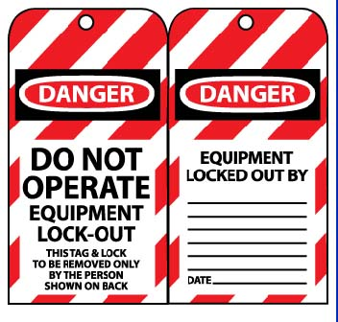

1. Example breaker lockout:

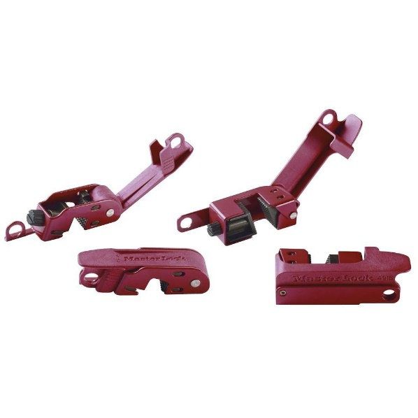

1. Example switch lockout:

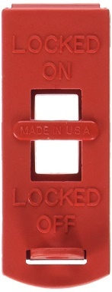

1. Example plug lockout:

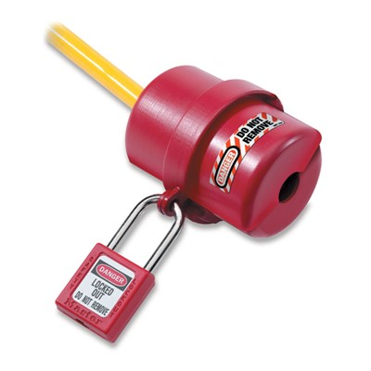

1. Example adjustable cable lockout:

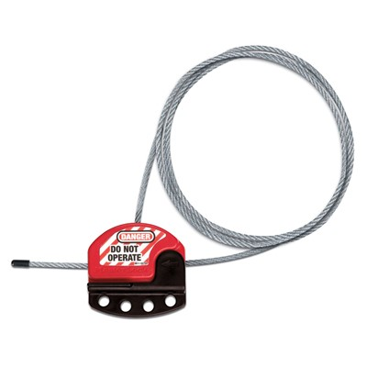

1. Example gate valve lockout:



1. Example plug valve lockout:

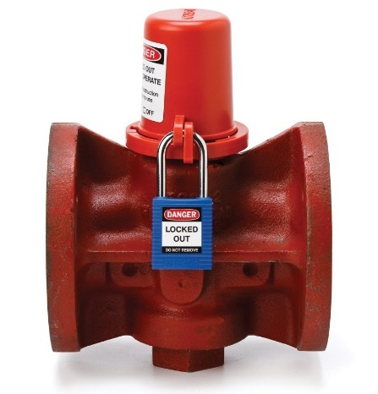

1. Example pneumatic fitting lockout:

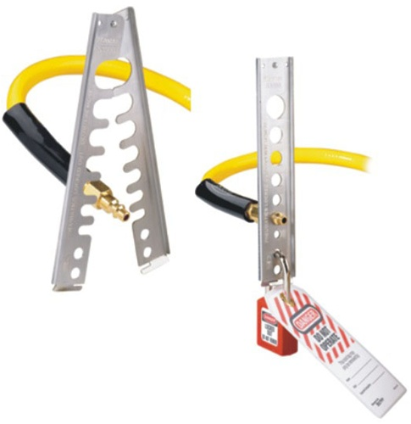

1. Example hasp lockout (for groups):

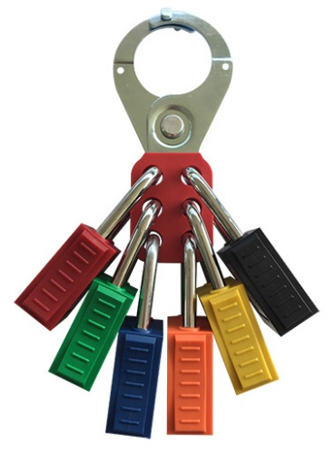

1. Example group lockout box:

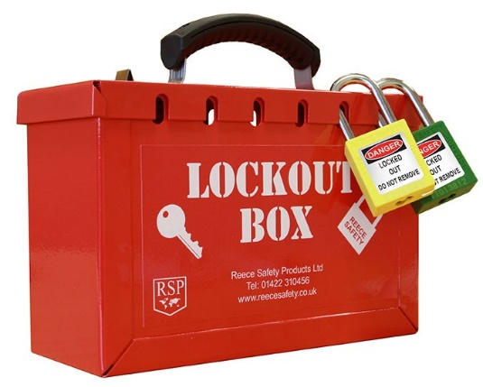

1. Example workplace lockout station:

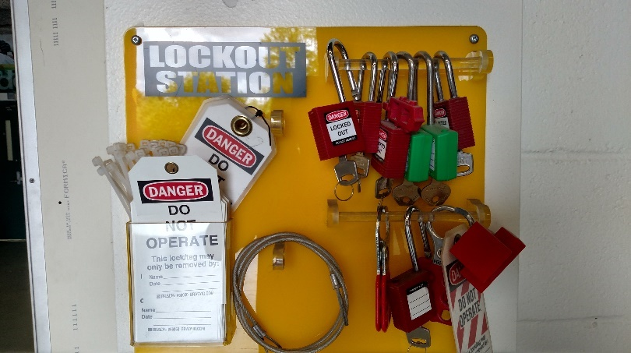

**Appendix B. – OSHA Interpretations**

**OSHA Interpretations to Common Questions**

**Question:** Is it permissible to consider a light switch a disconnecting means and lock out the light switch instead of the breaker when changing ballasts in fluorescent lights? This procedure breaches only one lead and if the switch is wired incorrectly may leave the ballast with a phase lead and ground.

**Reply:** Yes. It is permissible to use a light switch as a disconnecting means if the switch meets the requirements for a disconnecting means found in the National Electrical Code (NEC), NFPA 70-2005. It must be emphasized, however, that all of the requirements for locking and tagging out circuits under §1910.333(b)(2) apply (e.g., written procedures, application of locks and tags, etc.) whether you are using a circuit breaker as a disconnecting means or a light switch. <https://www.osha.gov/laws-regs/standardinterpretations/2005-10-27>

***Exclusive Control***  
**Scenario:** Maintenance is to be performed on a single piece of shop machinery, such as a lath or drill press. The machine has a single energy source which is a disconnect switch, located in clear view, within five unobstructed feet of the machine on an adjacent wall. An electrician placed the disconnect switch in the "off position, removed the fuses from the disconnect switch and the machine's control panel, and verified that the machine would not start. In order for another employee to reach the disconnect switch, they would need to walk past the employee performing maintenance on the machine.

**Question:** Is the disconnect switch "under the exclusive control" of the employee performing the maintenance, or is a lockout or tagout device still required to be placed on the disconnect switch?

**Reply:** OSHA's standard at Section 1910.147 includes provisions to protect employees performing servicing or maintenance of equipment from unexpected energization or start up. Section 1910.147(a)(2) *Application*, states:

(iii) This standard does not apply to the following:  
  
(A) Work on cord and plug connected electric equipment for which exposure to the hazards of unexpected energization or startup of the equipment is controlled by the unplugging of the equipment from the energy source and by the plug being under the exclusive control of the employee performing the servicing or maintenance.

The exception applies only to equipment that is de-energized through a cord and plug connection, and not to other forms of energy isolation devices, such as a disconnect switch. **Therefore, the disconnect switch described in the scenario above would need to be locked out and tagged out** in accordance with Section 1910.147(c) through (f), as well as Section 1910.333(b)(2). <https://www.osha.gov/laws-regs/standardinterpretations/2010-11-30>

**Question:** Is every lockout procedure required to have a periodic inspection, or can lockout procedures be grouped for machines that are of similar construction and operation?

**Reply:** An employer may group distinct procedures associated with similar machines or equipment and consider the group of distinct procedures to be a single procedure for purposes of conducting a periodic inspection if the machines or equipment in the group have the same or similar types of control measures. Grouping energy control procedures for same or similar machines or equipment for inspection purposes may streamline the inspection and review process, since there will be a smaller number of procedure groups than individual procedures. Thus, an employer may elect to group procedures as described above, and then inspect a representative number of such employees implementing one procedure within each group. This approach is acceptable if the inspection sampling reasonably reflects plant servicing and/or maintenance operations and hazardous energy control practices for the procedure being inspected. <https://www.osha.gov/laws-regs/standardinterpretations/2010-11-30>

**Appendix C. – Responsibilities and Definitions**

**Responsibility**

Management is to comply with and enforce all aspects of this program.

Supervisors or designees have implemented the “General Lockout Procedures” in this program for equipment requiring single point lockout. Supervisors or designees have developed as necessary, equipment specific energy control procedures for equipment meeting the criteria in the “Specific Lockout Procedures” section.

Supervisors are responsible for ensuring that authorized and affected employees receive training in energy control procedures.

Employees are to comply with all aspects of this program. Employees are to understand that violations of lockout procedures constitute a serious safety threat to themselves and others.

OSU’s Departmental of Environmental Health and Safety (EH&S) provides assistance in the development and implementation of, and training on lockout procedures.

**DEFINITIONS**

*Affected Employee:* An employee whose job requires him/her to operate equipment on which servicing or maintenance is being performed under energy controlled (locked-out) conditions, or whose job requires him/her to work in an area in which such servicing or maintenance is being performed.

*Authorized Employee:* A person who locks out equipment in order to perform service or maintenance activities. An affected employee becomes an authorized employee when that employee’s duties include performing servicing or maintenance.

*Crew Lockout:* More than one employee affixing a lock to a single or multiple energy isolating devices.

*Energy Isolating Device:* A mechanical device which physically prevents the transmission of energy. Examples include, but are not limited to: circuit breakers, manually operated disconnect switches, slide gates, slip blinds, line valves, blocks or similar devices with visible indication of the device’s position. Push buttons, selector switches and other controls are not energy isolating devices.

*Energy Source:* Any electrical, mechanical, hydraulic, pneumatic, chemical, thermal or other energy, including gravity, which could cause injury to employees.

*Lock Box:* A box which can be locked out, for use with crew lockouts or multiple point lockouts.

*Lockout Device:* A device requiring use of lock and key to hold an energy isolating device in the deactivated position. These include, but are not limited to: electrical plug caps, valve handle chains or covers, lockout hasps, circuit breaker lockouts and ball valve lockouts.

*Locked-Out Condition:* All energy sources to equipment are isolated and controlled through the application of locks, blinds, blocking and the dissipation of stored energy.

*Multiple Point Lockout:* Equipment having more than one energy source and/or more than one lockout point, requiring the application of multiple lockout devices to achieve a locked-out condition.

*Single Point Lockout:* Equipment requiring the application of a single lockout device to achieve a locked-out condition.

*Tag Out Device:* A tag placed on a locked-out energy isolating device to identity the authorized employees and to communicate that the equipment is in a locked-out condition.